Rue de Capucins 30, 1000, Brussels
+32 479 633 577, +32 2540 8473
ecyc@fcjmp.be, www.ecyc.org

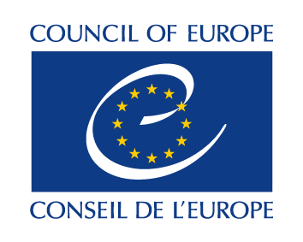 | 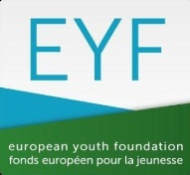 |  | 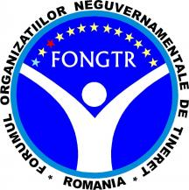

CALL FOR PARTICIPANTS
for an international working group on Youth policy and the role of youth work in preventing violent extremism of youth
25/10 - 28/10/2017, Brussels, Belgium

***To be returned to ecyc@fcjmp.be by the 15th of February 2017 at 12:00 CET ***
Please type, no handwriting!

Name of the applicant:
Home address:
Phone (private or direct contact number):
Phone (work/mobile):
Date of birth:
Sex:
E-mail:

Dietary requirements (please list allergies or if you require vegetarian, kosher, or halal food, etc):

Other comments or requirements (such as wheel-chair access, etc):

Contact person in your home organisation (name, telephone number and e-mail address):

Are you representing a member of an ECYC Member Organisation? Please state which organisation:

Are you representing another youth work or youth club organisation? Please state which organisation:

What is your main role and responsibility in your organisation?

What is your personal motivation to attend this international activity?

Please list the last trainings/educational activities you took part in at the local, national or European level, relevant to this call:

Please describe your strengths and weaknesses as a youth worker:

How you are planning to use your skills and knowledge gained through participation in this project in your organisation (local, national or international) in the coming 12 months?

***To be returned to ecyc@fcjmp.be by the 15th of February 2017 at 12:00 CET ***

