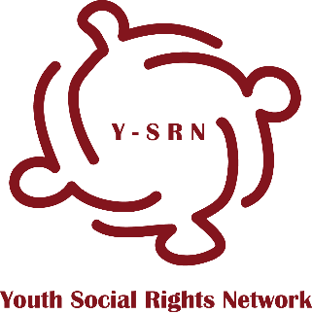

“ENTERTAINMENT – Bringing Social Rights to Our Local Agendas”

International training, 27 April – 1 May, 2017 (excluding arrival and departure days), Surami, Georgia

APPLICATION FORM

Deadline 24th of March, 2017
Please, send your application to the following email address:ysrnetwork@gmail.com

Please note, that this international training is a first phase of the project ‘’The Cinema of Social Rights’’. In case of selection for this training, you should commit to participate in the following phases of the project as well. For more details, please refer to the Call for Participation.

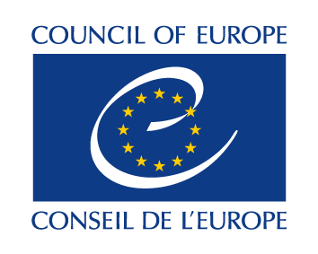
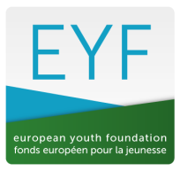

This project is supported by the European Youth Foundation of the Council of Europe

- Participant information
Name |  |  | Surname
Nationality |  | Age: |  | Sex | Male  Female  Other

- Contact information (Please note that all correspondence will be sent to this address – please ensure it is complete!)
Full home address
City and postal code |  | Country
Phone [with full international dial codes]  Mobile phone[with full international dial codes] |  | Fax  [with full international dial codes] if available
Email |  | Website
Facebook

- Information of sending organization
Do you belong to any organization | YES NO  (if you are applying as an individual please answer question #4)
Name of sending organisation or institution
Complete address
City and postal code |  |  | Country
Phone  [with full international dial codes] |  | Fax  [with full international dial codes] if available
Email |  | Website
How would you best describe your organisation? | - an International youth organisation  - national youth organisation  - local/regional youth organisation  - human rights association  - local authority/municipality  - governmental institution  - national youth council  - other (please specify)
Briefly describe your organization (structure, number of employees, general aim, field of work etc.)
Can you make decisions that bond your organization in future activities? | YES NO
What is your role/responsibility within your organisation?
Please specify, how will your organization support your participation, including implementation of follow up action plan?
- If you are not supported by the organization, please specify, how will you implement follow up action plan?
(please provide as detailed information as possible)

What is your professional status? | - a social worker  - a freelancer  - a youth worker  - a teacher  - other (please specify)

- Do you feel confident working in English?

Yes No

__________________________________________________________________________________
- Knowledge and experiences

What is your experience with topics related with young people, social rights, advocacy?

Have you attended any other international activity related to the topic of the training course? (if yes, which one(s))?

- Motivation and Expectations

What motivates you to participate in this activity?

What do you expect from this activity?

How can you contribute to this activity?

- Any other relevant information
Please share what else you want us you to know

- Are you committed and available to participate in all phases of the project?

- Special needs or requirements
Please send us all relevant information for any special needs or requirements (dietary restrictions allergies, disabilities, health related needs, etc.)

- Visas
If you are accepted as a participant on this training, will you require assistance in obtaining a visa to Georgia?

If yes, please indicate:

Date of birth:
Place of birth:
Passport No.:
Date of expiry:
Issued on:
Place:
Occupation (if employed) or student
Location of the embassy to be applied to

Person to contact in case of emergency
Name and relation (parent, partner, friend …)
Complete address
Postal code |  | City | Country
Phone  [with full international dial codes] |  |  | Fax  [with full international dial codes] if available
Email

Thank you for your application!

