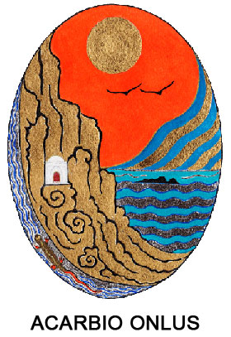

**INFO PACK**

***Together, diverse, outdoor***

***A UNIQUE OUTDOOR SEMINAR – LABORATORY TO TRY OUT DIFFERENT TOOLS FOR PROMOTING DIVERSITY AND INCLUSION***

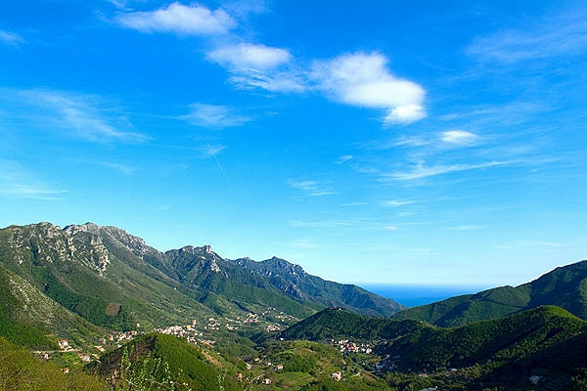

May 10th - 17th 2018, TRAMONTI (AMALFI COAST), ITALY

**Application deadline: Wednesday, March 28th**

**Application deadline 2nd call: Thursday, April 12th**

**INFO ABOUT THE PROJECT**

We are offering a very unique and special project – quite different from other Erasmus+ youth worker mobility projects you might have heard of OR experienced, so, probably you don’t want to miss it!!!

Seminar “Together, diverse, outdoor - nature learning space for diversity and inclusion” is quite experiential and experimental in its’ design. The main idea of it is **to gather experienced youth workers in order to share and develop together non-formal learning OUTDOOR tools that help to promote greater DIVERSITY and INCLUSION among youth**.

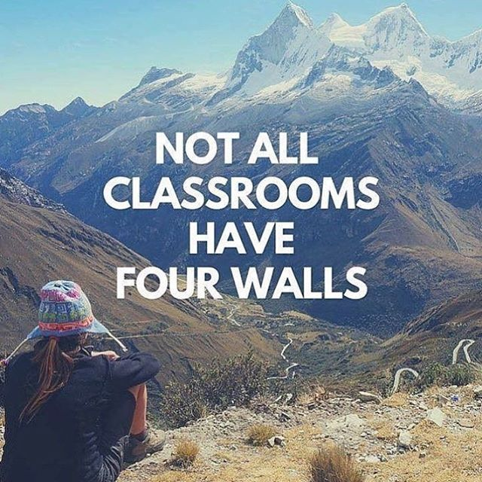

The seminar activities will partly take place indoors (3 days sleeping and working in monastery facilities) and partly outdoors (3 days in a camping place arranged by us in the mountains). The thematic focus of the seminar will be on sharing already existing and creating new non-formal learning tools that promote greater inclusion and diversity among young people - AND that can be implemented in the outdoors settings – using the power of nature. We believe that as people working with youth, we could and should play a larger role in supporting young people in developing more open attitudes towards diversity and promoting inclusion. We need more powerful approaches and tools for it! And, as we believe that the “truth is out there” – in the nature, with this seminar/laboratory, we want together with you to explore how to use it for youth work!

**PROFILE OF PARTICIPANTS**

As the contents of the project will largely depend on participants’ contributions in terms of sharing experiences working with young people, exploring challenges related to diversity and inclusion and developing outdoor activities that promote these values, we expect all participants to have a REAL experience in youth work and non-formal education for some time and maturity as personalities.

If the candidates offered by partner organizations will be too unsuitable, we keep the rights to choose other participants.

Here are the minimum criteria for participants:

* Involved in youth work for at least 1 year
* Have experience with providing non-formal learning activities for youth
* Have participated in at least 1 Erasmus+ project in the past
* Are interested in topics of diversity and inclusion and believe that these are values that need to be promoted
* Are interested in exploring learning in the nature/outdoors and ready to stay 3 nights in tents (and living in quite basic conditions)
* Within 2 months after the seminar - ready to implement at least 1 follow-up activity outdoors with their young people to promote diversity and inclusion

**PRACTICAL INFORMATION**

The training course will take place in the Amalfi Coast, south of Italy from May 10 to 17, 2018. This place is very famous around the world for its beautiful landscape and because it is listed among the UNESCO World Heritage sites (recognized as such since 1997). The Amalfi Coast has an ancient history for its main town, Amalfi, was an independent Maritime Republic from the 7th century until 1075, extracting itself from Byzantine vassalage in 839. It rivaled Pisa and Genoa in its domestic prosperity and maritime importance before the rise of Venice. The famous Amalfi Tables, a marinate code which was recognized in the Mediterranean until 1570, is a symbol of the prosperity and power once the Republic had. In medieval culture Amalfi was famous for its flourishing schools of law and mathematics. Flavio Gioia, traditionally considered the first to introduce the mariner's compass to Europe, was a native of Amalfi. The Republic rapidly declined in importance after it was attacked and conquered by the Normans in 1073 and later by the Pisans in 1137. Still today, the old town and the historic heritage of the area remind of those times. The most recognizable element of the landscape today, the terraces, have been built in Medieval time by monks in the many monasteries of this region, to enable agricultural productions.

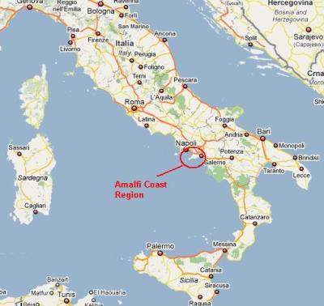

You will be located in **Tramonti**, a town at the Amalfi Coast, some kilometers inside the land and up the mountains. It was a strategically important part of the Maritime Republic of Amalfi, as it guarded the coast from any possible attack from the mountains. In fact, there once were several towers and military castles that could easily communicate any danger directly to the coast. Furthermore, it used to be and still is the green heart of the Coast and an important supplier for wood and agricultural products.

**ACCOMODATION**

You will be hosted in an old monastery build in 1487, where people are accommodated in a very mystic atmosphere. Rooms with private toilet will be shared by 2 or 3 participants of the same sex. Some people might be also asked to share a double-bed. We are sure you will enjoy the location as there is plenty of room and also a very nice colonnade. Some of the indoor activities will be held in the same building. You will be asked to bring your **sleeping bag** to be able to spend part of the training course in the wild for a unique experience. In fact the group will spend three consecutive nights camping on the mountains on top of the beautiful coast. (More detailed list of other things – closing, equipment, etc. needed for camping we will share later on.)

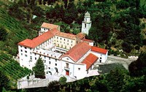

**TRAVEL COSTS AND TRANSFER**

**Arrival day:** May 10 | **Departure day:** May 17

Participants are responsible to book their tickets to Rome or Naples. We will reimburse travel expenses according to the travel budget approved by the NA and based on the distance calculator.

|  |  |  |  |
| --- | --- | --- | --- |
| **Organization** | **Number of participants** | **From** | **Travel budget per 1 person** |
| Sporta klubs Teku Taku | 4 | Kuldiga novads, Latvia | Eur 275 |
| EESTI PEOPLE TO PEOPLE | 3 | Tallinn, Estonia | Eur 360 |
| Stowarzyszenie Dorosli-Dzieciom | 3 | Sępólno Krajeński, Poland | Eur 275 |
| Grupo de Desarrollo Rural Valle del Guadalhorce | 3 | Cerralba, Pizarra (Málaga), Spain | Eur 275 |
| Asociace TOM CR, TOM 21105 DUMANCI | 3 | Stádlec, Czech Republic | Eur 275 |
| National Youth Card Association | 3 | Gabrovo, Bulgaria | Eur 275 |

The table above shows the limit we can reimburse for each organization. Please keep also in mind, that to your travel expenses you will have to add a fee for the local transport to Tramonti.

**We ask for selected participants to confront with us first to buy any ticket as we can suggest you the best route and find the cheapest solution.**

**HOW TO APPLY**

In order to apply, you have to fill the application form online: [https://docs.google.com/forms/d/e/1FAIpQLSeyWYnDrrFW1IM8Wflit27-jfM2-Dszq87sjQeqJh8d4awnTg/viewform?usp=sf_link](https://docs.google.com/forms/d/e/1FAIpQLSeyWYnDrrFW1IM8Wflit27-jfM2-Dszq87sjQeqJh8d4awnTg/viewform?usp=sf_link%20) and submit it by Wednesday, March 28 the very latest. Update: We accept applications until Thursday, April 12th.

If your organization already knows the participants AND they perfectly fit the profile, please ask them to apply even sooner so that you can start buying tickets as soon as possible.

Remember that in Erasmus+ there are the travel limits, so, the sooner you buy the tickets, the bigger the chance that you can get reimbursed even 100%.

***Should you have any more questions, please do not hesitate to ask!***

***We are looking forward to spending some exciting and inspiring days with you here in beautiful Tramonti!***

|  |  |  |  |  |  |  |  |  |  |
| --- | --- | --- | --- | --- | --- | --- | --- | --- | --- |
| Preliminary Programme | | | | | | | | | |
| **Time / day** | **Day Arr** | **Day 1** | **Day 2** | **Day 3** | **Day 4** | | **Day 5** | **Day 6** | **Day Dep** |
| 8.30 - 9.15 | Arrivals |  | | | | | | |  |
| 9.30 - 11.30 | Intro, programme, approach, motivation and Youthpass  Ice-breaking activities | Crash courses on: facilitating NFL activities & Outdoor approach and safety issues | Power of Outdoor learning and learning in the nature | Lab: Implementing and testing the tools I | | Lab: RE-Testing some tools and reflection | Self-directed learning session - exploring the remaining questions about topic of Diversity and Inclusion and Outdoor Experiential Learning | Closing ritual of "saying goodbye to nature"  Farewell and departure |
|
|
| 11.30 - 12.00 |  |  | Coffee break |  |  |  |  |
| 12.00 - 13.30 | Team-building activities outdoors (co-organized by participants) | Exploring Amalfi Coast with a local guide - getting to know the insider stories of history, nature, issues of young people and life there | Power of Outdoor learning and learning in the nature  Intro to Lab phase | Lab: Implementing and testing the tools II | | Lab: RE-Testing some tools and reflection | Reflection: Me as a youth worker applying learning in/from nature and outdoors as an approach   Erasmus+ opportunities |
|
|
|
| 13.30-15.30 | Lunch | | | | | | |  |
| 15.30-17.00 | Openning discussion on: Diversity and Inclusion and Learning in/from the Nature and Outdoor education | Start of Outdoor Part - Hike to camping place with adventure elements | Lab: Working in smaller teams – designing NFL tools for Diversity and Inclusion | Lab: Implementing and testing the tools III | | Summing up of practical phase – lessons learnt | Follow-up activity planning in national groups  Reflection on learning outcomes of the seminar and Youthpass |  |
| 17.00 - 17.30 | Coffee break | Coffee break | | | | |  |
| 17.30 - 19.00 | Getting to know each other | The needs of young people and set of competences to contribute to greater appreciation of diversity and promotion of inclusion | Hike to camping place with adventure elements and arranging the camp | Lab: Working in smaller teams – designing NFL tools for Diversity and Inclusion | Lab: Implementing and testing the tools IV | | Packing and hiking back to "indoors" | Summing up  Evaluation  Closing |  |
|  |
|  |
| 19.00-19.30 | Reflection group | Time for reflection in group | | | | |  |
| 20.00 | Welcome Dinner | Dinner | | | | | | Farewell dinner and evening |  |
| After 21.00 | Story evening - own adventures in nature | Evening check-in | Our Childhood Games Outdoors evening | Evening programm organised by the participants | | Local evening |  |